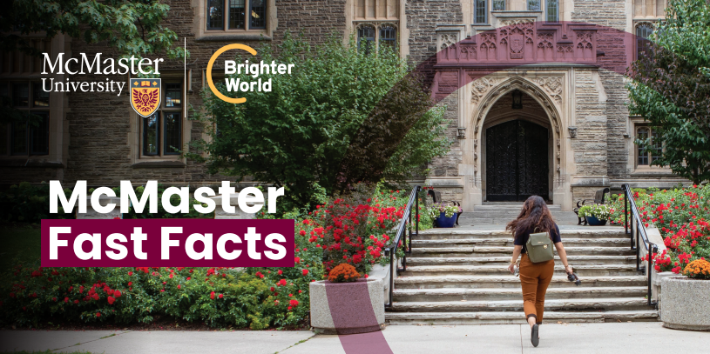

# McMaster Fast Facts

## Our Mission:

At McMaster, our purpose is the discovery, communication and preservation of knowledge. In our teaching, research and scholarship, we are committed to creativity, innovation and excellence. We value integrity, quality, inclusiveness and teamwork in everything we do. We inspire critical thinking, personal growth and a passion for lifelong learning. We serve the social, cultural and economic needs of our community and our society.

### Our History

* Founded in 1887 in Toronto through a bequest from Senator William McMaster, a member of the first senate after Confederation, founding president of the Canadian Imperial Bank of Commerce and chair of the Great Western Railway.
* Relocated from Toronto to Hamilton in 1930.
* Maroon and grey were adopted as the official colours in 1912

### Our Strengths

* Consistently ranked among Canada’s most research-intensive universities by Research Infosource (2024).
* Ranked 3rd among Canada’s medical/doctoral schools in the Research University of the Year ranking by Research Infosource (2024).
* Ranked 101-150 in the world by Shanghai Ranking's Academic Ranking of World Universities 2024.
* Ranked 30th in the world in Times Higher Education’s University Impact Rankings 2024, based on the Sustainable Development Goals of the United Nations.
* Winner of the 2018 Global Teaching Excellence Award from the Higher Education Academy for our strengths in experiential learning and our commitment to global engagement.
* Ranked #1 for Graduate Student Research Intensity by Research Infosource (2024).
* The McMaster Model, a problem-based, student-centred approach to learning, has been adopted worldwide.
* Home to 70 research centres and institutes.
* More than 70 international exchange agreements.
* World-class athletic facilities; National women’s basketball champions (2019) and national football champions (2011).

### Our Students

* 32,105 undergraduates and 5,487 graduate students, for a total student population of 37,537.
* In the 2023/2024 academic year, 17% of all McMaster students were international students, from 120 countries.
* International graduate students represented 31.1% of the graduate student body in fall 2023/2024.
* The percentage of undergraduate students registering with an admission average of 90% and above has risen from 13.9% in 2000 to 65.2% in 2023/2024.

### Our Alumni

* More than 244,915 alumni represent 143 countries, including Canada.
* Cabinet ministers, business leaders, scientists, university presidents, Hollywood actors, Olympians, an astronaut.
* Nobel laureates: Bertram Brockhouse (professor emeritus), co-winner of the 1994 Nobel Prize for Physics; alumnus Myron Scholes, co-winner of the 1997 Nobel Prize for Economics; alumnus James Orbinski, alumna Donna Strickland, co-winner of the 2018 Nobel Prize for Physics.

### Our Faculty and Staff

* 992 full-time instructional faculty members (excluding clinical educators).
* Our research intensity averages $407,300 per faculty member (“Research intensity” measures research income per full-time faculty member.)
* 124 chairs, 13 professorships, 86 allotted Canada Research Chairs, one Canadian Institutes of Health Research Chair, two Ontario Research Chairs.
* Selected as a Hamilton-Niagara Top Employer for the past nine years in a row.
* Recognized as one of Canada’s Best Diversity Employers for six consecutive years.
* Ranked 85th in the world and 5th in Canada in the 2024 Global Employability Ranking.
* Employing more than 19,000 faculty, research, staff, student and interim employees.

### Our Campus and Location

* 300 acres of scenic property with 30 acres designated as a central core pedestrian campus.
* Explore the natural beauty in McMaster’s own backyard at [mcmaster.ca/nature/](http://mcmaster.ca/nature/).
* Four libraries, an athletics complex, a research reactor, a planetarium, and the McMaster Museum of Art.
* Regional campuses in Burlington, Kitchener-Waterloo, Niagara, and downtown Hamilton.