Updated July 2024

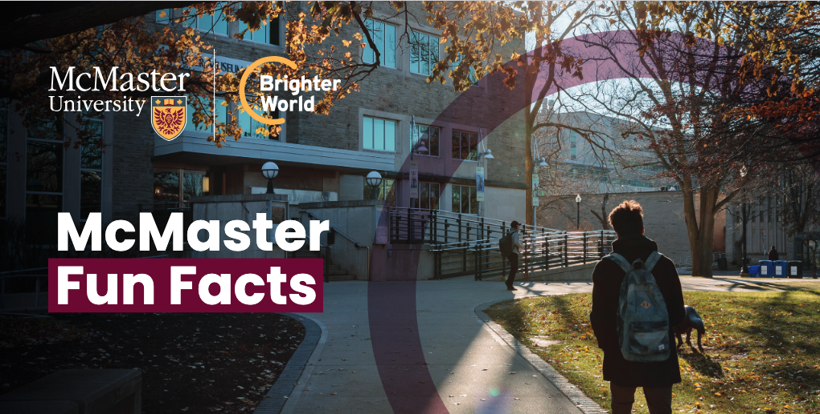

McMaster Fun Facts

The Brains of the Operation
- One-fifth of Einstein’s brain is floating in a jar of alcohol in a McMaster science lab.
- McMaster neuroscientist Sandra Witelson has been studying the great man’s grey matter for more than 20 years.
- After all, as Einstein said: “It’s not that I’m so smart. It’s just that I stay with problems longer.”

Comedy Begins Here
- Martin Short, Eugene Levy and Dave Thomas all graduated from McMaster in the 1970s.
- Ivan Reitman (director of National Lampoon’s Animal House, Meatballs, and Ghostbusters) graduated from Mac in 1969.

A Timeless Timepiece
- The sundial on the front of Hamilton Hall was a gift from the Class of Arts of 1928.
- The inscription “AUT DISCE AUT DISCEDE” has been translated in various ways: “Either learn or leave,” “Shape up or ship out,” and “Cram or scram.”

No, That’s Not the Reactor
- The tall tower you see on campus is connected to a two-kilometre underground tunnel system that provides the campus with its heating, cooling and electricity.
- It’s located in the E.T. Clarke Centre, where you’ll also find Security & Parking Services — but not the McMaster Nuclear Reactor.

I Can Hear the Bells
- Every Monday at 2 o’clock, the McMaster campus is treated to a live carillon concert.
- Played on real bells in the McMaster Divinity College’s tower, the music welcomes all to the weekly chapel service.

A Message From Gandhi
- “A teacher who establishes rapport with the taught, becomes one with them, learns more from them than he teaches them.”
- A bust of Ghandhi, donated by the Government of India, meditates quietly near the Office of the President in Gilmour Hall.

A Stroll Through Campus:
- The McMaster Museum of Art houses five galleries and more than 6,000 works of art from ancient times to the present. Along with works by Matisse, Monet, Pissarro, Van Gogh and many others, the museum’s vast holdings include lithographs, drawings, etchings, sculptures, coins, maps, and even photos of Hollywood stars of yore: museum.mcmaster.ca
- McMaster’s four libraries have combined collections of more than 1.9 million print and electronic books, 86,000 print and electronic journal titles, and 14,000 linear feet of archival resources. The library’s archives are home to rare maps, medieval manuscripts, and archival collections from icons such as Anthony Burgess, Leonary Cohen, Farley Mowat, and Bruce Cockburn. The oldest map in the collection is a 1486 reproduction of a map by Ptolemy which depicts the British Isles as they were known in the time of the Roman Empire.
- The Bertrand Russell Archives, now located at 88 Forsyth Avenue North, are an unparalleled collection of books, papers and memorabilia from the archives of the renowned peace activist, philosopher and Nobel laureate. There’s even a Christmas card from John and Yoko.
- The W.J. McCallion Planetarium was the first of its kind in Ontario to offer public shows. Its original dome was a war-surplus parachute suspended from the ceiling. Now located in the Burke Science Building, it offers family- friendly public shows, with seats for 35 and two wheelchair spaces: physics.mcmaster.ca/planetarium
- The McMaster Nuclear Reactor was opened in 1959, the first university-based research reactor in the British Commonwealth. Today, it is one of the world’s largest suppliers of the medical radioisotope iodine-125, used in the treatment of prostate cancer.

