Updated July 2024

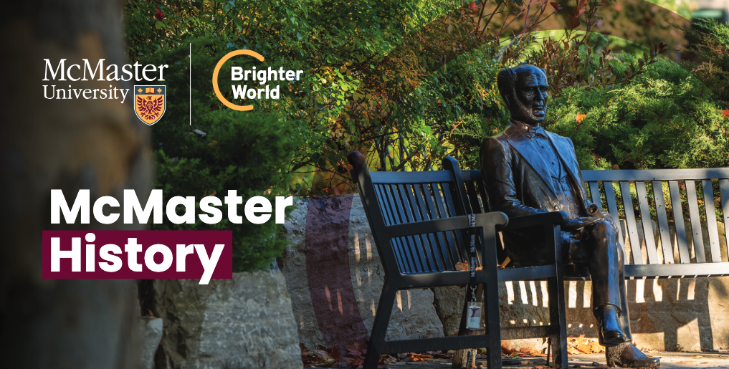

McMaster History

1887
- McMaster University is founded in Toronto from a bequest of $900,000 from the estate of Senator William McMaster.
- The first three Faculties were Arts, Science and Divinity, as engraved in the stones of the Class of 1954 Oasis Garden on campus.

1930
- McMaster University moves from Toronto to Hamilton. The lands and new buildings are secured through gifts totalling $500,000 from alumni, members of the churches of the Baptist Convention of Ontario and Quebec, and citizens of Hamilton.

1957
- Originally founded as a Baptist university, McMaster becomes a publicly funded, non-denominational institution.

1959
- The McMaster Nuclear Reactor, the first university-based research reactor in the British Commonwealth, begins operations.
- Today, it is one of the world’s largest suppliers of the medical radioisotope iodine-125, used in the treatment of prostate cancer.

1965
- McMaster establishes a medical school and teaching hospital.
- The medical school goes on to pioneer “problem-based learning,” known around the world as the McMaster Model.

1967
- McMaster scoops the global community by purchasing the archives of Nobel laureate and peace activist Bertrand Russell.

1968-69
- McMaster Divinity College continues under its existing arrangement, while the rest of McMaster University is organized into the Divisions of Arts, Science and Health Sciences, each headed by a vice-president (academic).

1974
- The Faculties of Business, Engineering, Health Sciences, Humanities, Science and Social Sciences are established, each under the leadership of a dean.

1981
- The Arts & Science Program is established, breaking new ground in self-directed, interdisciplinary undergraduate education.

1994
- Bertram Brockhouse, a professor at Mac from 1962 until his retirement in 1984, is co-winner of the Nobel Prize in Physics.

1997
- Alumnus Myron Scholes is co-winner of the Nobel Prize in Economics.

1999
- Alumnus James Orbinski, then international president of Médecins Sans Frontières, accepts the Nobel Peace Prize for MSF.

2003
- Michael G. DeGroote gives McMaster $105 million, the largest cash gift in the history of Canadian universities until 2019.

2018
- McMaster is chosen from 16 global finalists to win the Global Teaching Excellence Award.
- Alumna Donna Strickland co-wins the Nobel Prize in Physics, the first woman in 55 years to achieve this honour.

2020
- Hamilton philanthropists Charles and Margaret Juravinski create an endowment of more than $100 million to support researchers across Hamilton Health Sciences, McMaster University and St. Joseph’s Healthcare Hamilton.

