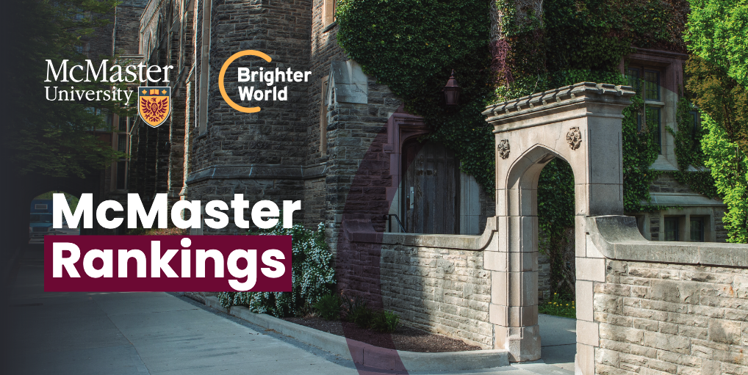

# McMaster Rankings

## Global Rankings

### Times Higher Education Impact Rankings 2024

* **#30 in the world** for Global Impact
* **#4 in Canada**
* **#7 in the world** for Clean Water and Sanitation and #1 in Canada
* **#15 in the world** for Good Health and Well-Being and #1 in Canada
* **#27 in the world** for Partnership for the Goals and #1 in Canada
* **#28 in the world** for No Poverty and #6 in Canada
* **#35 in the world** for Reduced Inequalities and #2 in Canada
* **#53 in the world** for Industry Innovations and Infrastructure and #4 in Canada

### Times Higher Education World University Rankings 2025

* **#116 in the world** and **#4 in Canada**
* **#36 in the world** in Clinical and Health
* **#101-125 in the world** in Life Sciences

### GEURS, the Global Employability University Ranking and Survey 2025, by EMERGING and published by Times Higher Education

* **#85 in the world** and **#5 in Canada**

### ShanghaiRankings Consultancy Academic Rankings of World Universities (ARWU) 2024

* **#101-150 in the world** and **#5 in Canada**
* **#36 in the world** in Public Health and **#4 in Canada**
* **#48 in the world** in Clinical Medicine and **#2 in Canada**

### QS World University Rankings 2025

* **#176 in the world** and **#8 in Canada**
* QS World University Rankings by Subject 2024: **#33** in Nursing, **#32** in Sports-Related Subjects, **#44** in Anatomy & Physiology, **#43** in Medicine, and **#55** in the “Broad Subject Area” of Life Sciences & Medicine.

### QS World University Rankings: Sustainability 2025

* **#93 in the world** and **#9 in Canada**
* **#56 in the world** for Environmental Education and **#7 in Canada**
* **#77 in the world** for Social Impact and **#10 in Canada**

### QS Graduate Employability Rankings 2022

* **#81 in the world** and **#4 in Canada**

### U.S. News - Best Global Universities Rankings 2024-2025

* **#127 in the world** and **#4 in Canada**

### CWTS Leiden Rankings 2024

* **#169 in the world** and **#8 in Canada**

### Center for World University Rankings (CWUR) 2024

* **#171 in the world** and **#6 in Canada**

### National Taiwan University: Performance Ranking of Scientific Papers for World Universities: 2024

* **#128 in the world** and **#5 in Canada**
* **#53 in the world** in Clinical Medicine
* **#62 in the world** in Social Sciences
* **#57 in the world** in Medicine, as a field
* **#85 in the world** in Social Sciences, as a field

## Canadian Rankings

### Maclean’s University Rankings 2025

* **#4 in Canada** in the “medical-doctoral” category. (Universities in this category have a broad range of research opportunities and PhD programs, as well as medical schools.)
* **#1 in Canada** for student services, **#2** for Total Research Dollars, **#2** for Library Acquisitions, **#2** for medical/science grants and **#5** for Faculty Awards.

### Research Infosource Inc. 2024

* **Ranked 3rd** for Research Universities of the Year 2024
* **Ranked 1st** for Graduate Student Research Intensity
* **Ranked 1st** for Research Income Growth, attracting $465.9M
* **Ranked 2nd** for corporate research income, attracting nearly $100 million in investments from the private sector
* **Ranked 2nd** for Faculty Research Intensity
* “Research intensity” measures research income per full-time faculty member or graduate student